PERSONALIZED AFFECTIVE FEEDBACK TO ADDRESS STUDENTS’ FRUSTRATION IN ITS

**ABSTRACT:**

The importance of affective states in learning has led many Intelligent Tutoring Systems (ITS) to include students’ affective states in their learner models. The adaptation and hence the benefits of an ITS can be improved by detecting and responding to students’ affective states. In prior work, we have created and validated a theory-driven model for detecting students’ frustration, as well as identifying its causes as students interact with the ITS. In this paper, we present a strategy to respond to students’ frustration by offering motivational messages that address different causes of frustration. Based on attribution theory, these messages are created to praise the student’s effort, attribute the results to the identified cause, show sympathy for failure or obtain feedback from the students.We implemented our approach in three schools where students interacted with the ITS. Data from 188 students from the three schools collected across two weeks was used for our analysis. The results suggest that the frustration instances reduced significantly statistically (p < 0.05), due to the motivational messages. This study suggests that motivational messages that use attribution theory and address the reason for frustration reduce the number of frustration instances per session.

**ARCHITECTURE:**

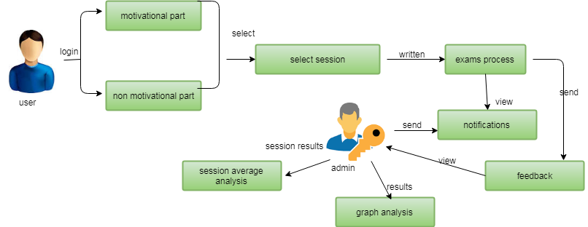

**EXISTING SYSTEM:**

The review paper [18] discusses the research works inresponding to learners’ affective states. In this section,we focus on the systems (ITS and Educational games)which detect and address the students’ affective states while they interact with the system. We describe five such systems in this section.. To study the effect of three types of responses to frustration – ignore students’ frustration, collect feedback from students, and provide messages – an affect-support. computer game [4], induces frustration by freezing the screen when the students play the game. The first type “Ignore students’ frustration” provides no motivational messages and does not collect feedback from the users.The second type “Collect feedback” collects the studentfeedback in terms of how they feel, but and does not provide any motivational messages. In the third type, the system provides feedback messages and sympathy messages

whenever the user reports frustration. The impactof responses provided to the students was analyzed using data from 71 students. Students’ frustration is identified by self-reporting using questionnaires. According to the reported analysis, students felt significantly less frustrated when playing the game without freezing than the game playing with freezing. The students who got feedback message and empathy messages played the game for significantly more time than the students who got no messages implying that responding to frustration

by providing motivation has an impact on students’frustration.

**PROPOSED SYSTEM:**

In this subsection, we describe the step 8 in Figure 2 ofour approach, that is the algorithm to display motivational messages. For the events listed in Table 2, that is for each goal failure, we show the messages based on the student’s response time in answering the questions from Mindspark, and question type. We restrict the number of messages per Mindspark session to three. This is to limit the number of interventions to the students during their interaction with Mindspark and avoid students not to focus on feedback messages. The algorithm to display a message based on frustration instance is shown in The condition to display messages for second and third instances of frustration is described in the algorithm 1. In next section we describe the research design and impact of motivational messages provide to students. To determine the impact of the motivational messages, we use the within-groups research design (repeated measures) that is comparing the results of our approach to responding to frustration against a control condition.

The experimental condition is that students receive motivational messages based on our proposed model and schools were chosen to represent different cities in India have minimum 100 class 6 students. The theoretical model to detect frustration was developed using data from class six students, hence we collected the data of class six student from three schools. We collected data from 769 class six students, **MODULES:**

1. **Session Model**

The session model is processing the user select the examination and tutorial sessions is providing the various exam sets in the students for coverts the message and non motivational messages is send to the exam points of view in students for the various students is associating the sessions.

1. **Motivational model.**

The content in our motivational messages is based on

strategies recommended in existing literature and attribution

theory. Attribution theory implies that motivating students’ by messages which attribute the failure to external factors (such as math, the difficulty of the question) will motivate them to set a new goal. We request feedback from a student after detecting frustration and displaying feedback messages to show empathy for students’ affective state. Using the recommendation from , our motivational messages are displayed using the agents who communicate empathy in their messages.

**3.Non Motivational Message**

To determine the impact of the motivational messages,

we use the within-groups research design (repeated measures) that is comparing the results of our approach to responding to frustration against a control condition. The experimental condition is that students receive motivational messages based on our proposed model and schools were chosen to represent different cities in India have minimum 100 class 6 students. The theoretical model to detect frustration was developed using data from class six students, hence we collected the data of class six student from three schools

**4.Graphical Representations**

The number of frustration instances in 188 sessions are

visually represented using the box plot in . The frustration instances without and with motivational messages. As seen in the box plots, the number of frustration instances after implementing motivational messages is reduced. The circle indicates outliers; this means that the number of frustration instances per session being equal to six is only two after implementing motivational messages to mitigate frustration.

**ALGORITHM:**

Linear regression

### Printer-friendly version. Simple linear regression is a statistical method that allows us to summarize and study relationships between two continuous (quantitative) variables: One variable, denoted x, is regarded as the predictor, explanatory, or independent variable.

Regression analysis is a reliable method of identifying which variables have impact on a topic of interest. The process of performing a regression allows you to confidently determine which factors matter most, which factors can be ignored, and how these factors influence each other.

In order to understand regression analysis fully, it’s essential to comprehend the following terms:

* **Dependent Variable:** This is the main factor that you’re trying to understand or predict.
* **Independent Variables:** These are the factors that you hypothesize have an impact on your dependent variable.

In our application training example above, attendees’ satisfaction with the event is our dependent variable. The topics covered, length of sessions, food provided, and the cost of a ticket are our independent variables.

In order to conduct a regression analysis, you’ll need to define a dependent variable that you hypothesize is being influenced by one or several independent variables. You’ll then need to establish a comprehensive dataset to work with. Administering surveys to your audiences of interest is a terrific way to establish this dataset. Your survey should include questions addressing all of the independent variables that you are interested in. Let’s continue using our application training example. In this case, we’d want to measure the historical levels of satisfaction with the events from the past three years or so (or however long you deem statistically significant), as well as any information possible in regards to the independent variables. Perhaps we’re particularly curious about how the price of a ticket to the event has impacted levels of satisfaction.

**FUTURE WORK:**

In this subsection, we describe the step 8 in Figure 2 ofour approach, that is the algorithm to display motivational messages. For the events listed in Table 2, that is for each goal failure, we show the messages based on the student’s response time in answering the questions from Mindspark, and question type. We restrict the number of messages per Mindspark session to three. This is to limit the number of interventions to the students during their interaction with Mindspark and avoid students not to focus on feedback messages. The algorithm to display a message based on frustration instance is shown in The condition to display messages for second and third instances of frustration is described in the algorithm 1. In next section we describe the research design and impact of motivational messages provide to students. To determine the impact of the motivational messages, we use the within-groups research design (repeated measures) that is comparing the results of our approach to responding to frustration against a control condition.

The experimental condition is that students receive motivational messages based on our proposed model and schools were chosen to represent different cities in India have minimum 100 class 6 students. The theoretical model to detect frustration was developed using data from class six students, hence we collected the data of class six student from three schools. We collected data from 769 class six students, **CONCLUSION:**

In this paper, we have discussed our approach to respond to frustration using motivational messages. The approach we developed for Mind spark was based on addressing students’ goal failure. Our approach has been implemented and tested successfully. The results show that motivational messages that use attribution theory and address the reasons for frustration reduced the number of frustration instances per session. The reduction in the number of frustration instances is statistically significant. Motivational messages help the students to

reduce frustration and continue with their session, thus enabling them to avoid the negative consequences of frustration. Our approach can be generalizable to Math topics and class 6 students in schools, in Mindspark. To apply our approach to other systems, the reasons for frustration should be identified while detecting it. Moreover, careful

thought is required while creating the messages based on the goal-failure. To generalize our approach to respond to other affective states, the theory-driven approach should be used to detect the affective state, since it enables identification of the reason for the affective state.

Subsequently, the reason can be used to respond to the ffective state, along lines similar to our approach.